

**PROJECT DOCUMENTS**

**Project Title**

**Environmental Monitoring**

* Analyze environmental data (e.g., Pollution)

for a conservation organization or government agency.

* Visualize environmental indicators using heatmaps, time series plots, or satellite imagery.

**Team Number &** **Teammates:**

Team:3

720722104013-GOPINATH K

720722104033-RENITH M

720722104034-ROHITH S

720722104040-SREYA S

**Department:**BE.CSE

**Year:** IInd Year

**Description About the project**

1.Identify Environmental Data Sources:

Begin by identifying reliable sources of environmental data relevant to your chosen indicators (Pollution). Government agencies, research institutions, and environmental organizations often provide datasets that can be used for analysis.

**2.Data Collection and Preparation:**

Acquire the necessary datasets and ensure they are clean, organized, and formatted correctly for analysis. This step may involve data cleaning, handling missing values, and standardizing data formats.

**3.Define Analytical Objectives:**

Clarify the specific objectives of your analysis. For example:

Assess trends and patterns in air quality over time and across geographical regions.

Analyze water quality parameters and identify pollution hotspots.

Monitor changes in forest cover and deforestation rates.

**4.Data Analysis Techniques:**

Apply appropriate statistical and analytical methods to gain insights from the data:

* Descriptive Statistics: Calculate summary statistics (mean, median, standard deviation) for each environmental indicator.
* Time Series Analysis: Examine changes in environmental variables over time using time series plots.
* Spatial Analysis: Use GIS (Geographic Information System) tools to analyze spatial patterns and create heatmaps.

**5.Visualization Methods:**

Create visual representations of the analyzed data to facilitate understanding and decision-making:

* Heatmaps: Display spatial variations of environmental indicators (e.g., air quality index) using color gradients.
* Time Series Plots: Illustrate trends and seasonal variations in environmental variables over time.
* Satellite Imagery Analysis: Utilize satellite images to monitor land cover changes, deforestation, or urban expansion.

**Tools and Technologies:**

**Data Analysis Tools:** Python (with libraries like Pandas, NumPy, Matplotlib, Seaborn), R, or specialized GIS software (e.g., QGIS, ArcGIS).

**Visualization Tools:** Matplotlib, Seaborn, Plotly, Tableau, GIS software for mapping and spatial analysis.

**Satellite Imagery Platforms:** Google Earth Enginw

**Code and Output**

**IMPORTING LIBRARIES:**

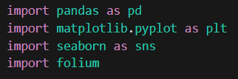

**READ DATASET:**

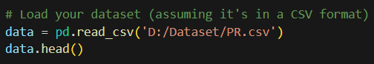

OUTPUT:

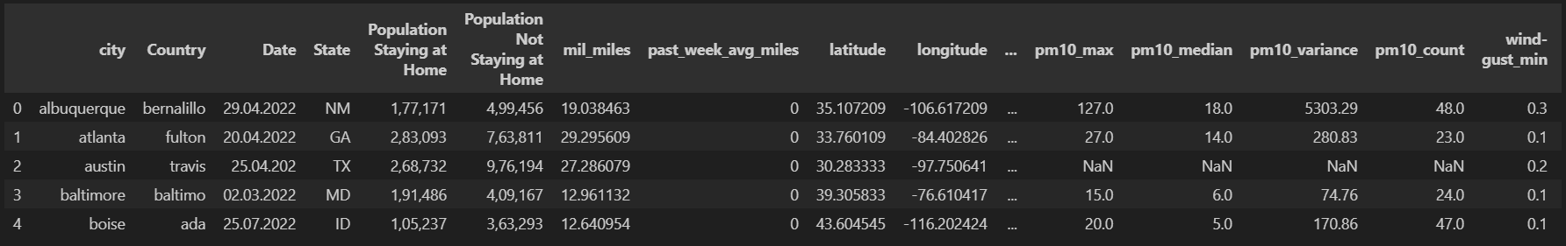

**HISTOGRAM:**

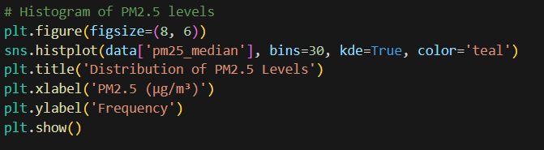

**OUTPUT:**

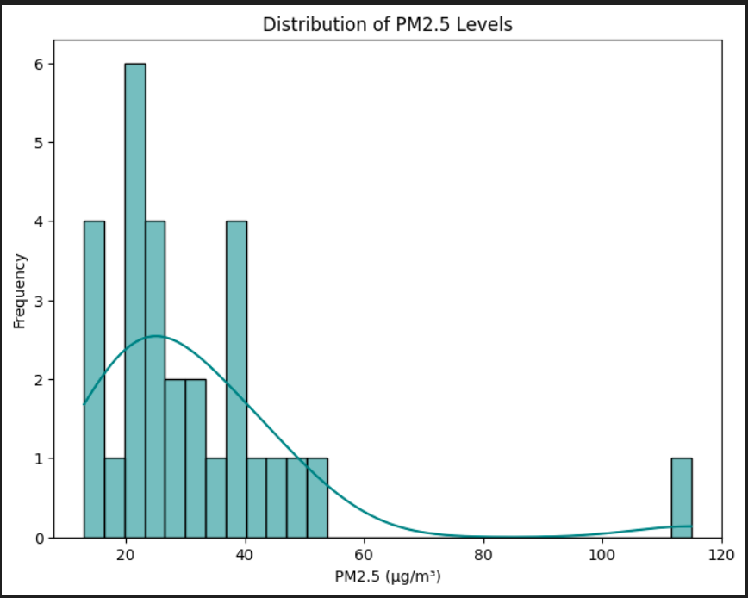

**SCATTER PLOT:**

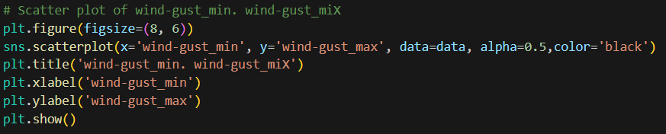

**OUTPUT:**

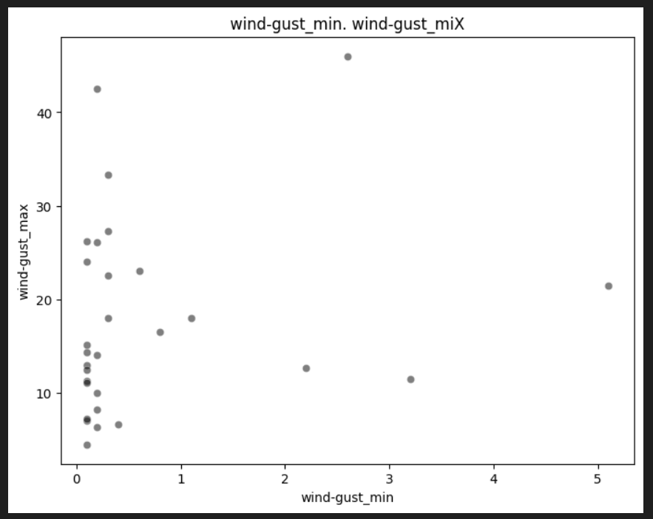

**GEOSPATIAL MAPPING:**

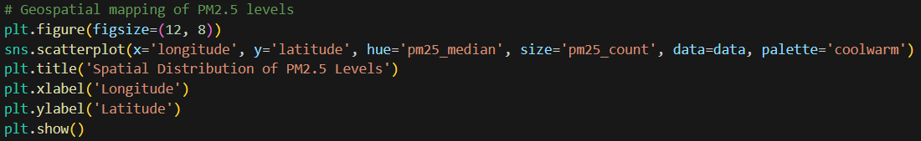

**OUTPUT:**

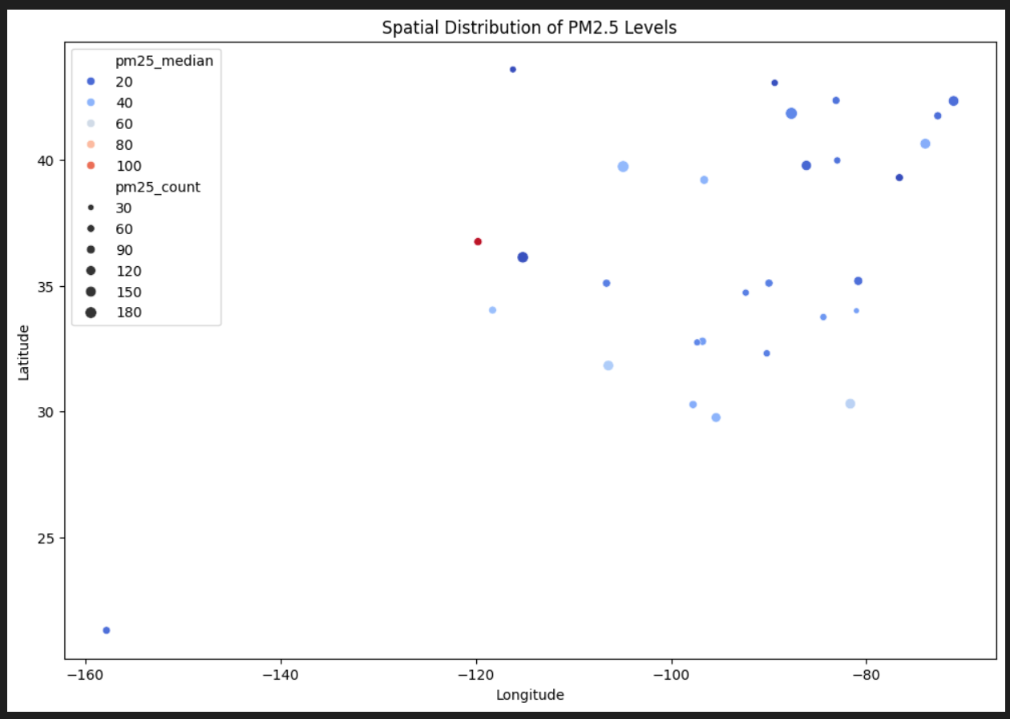

**HEATMAP:**

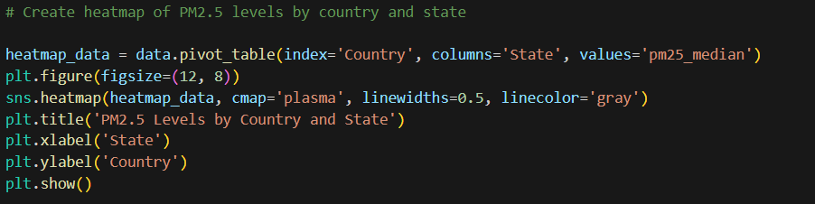

**OUTPUT:**

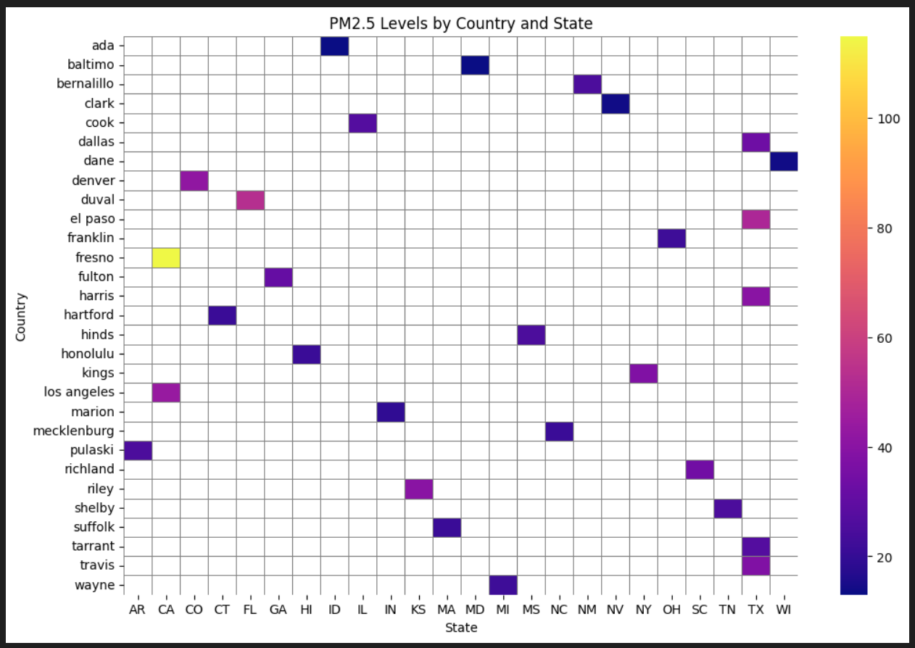

**AREA CHART:**

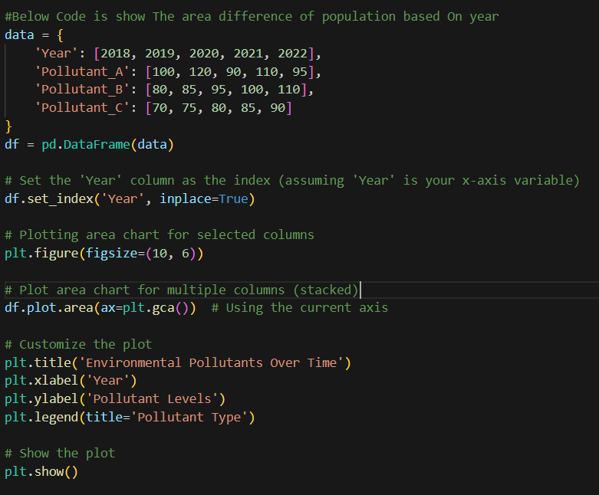

**OUTPUT:**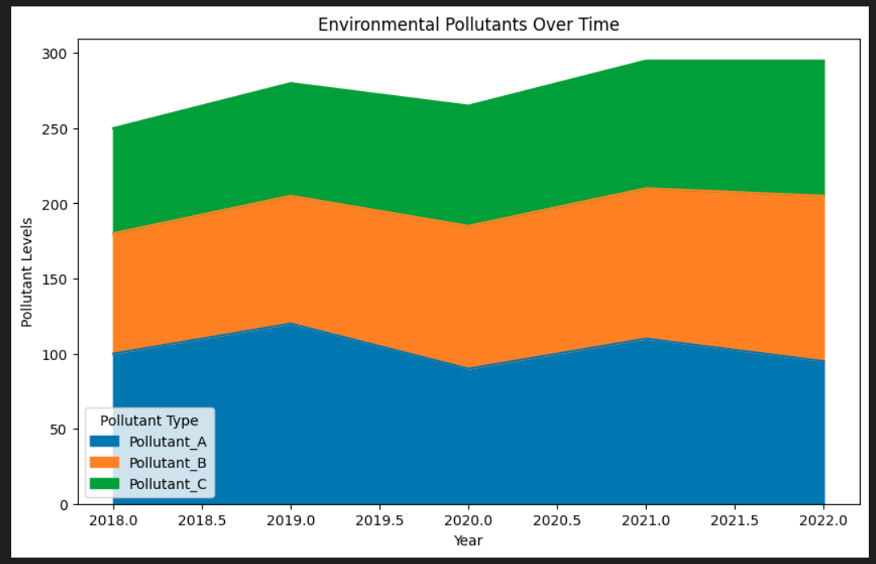

**PIE CAHRT:**

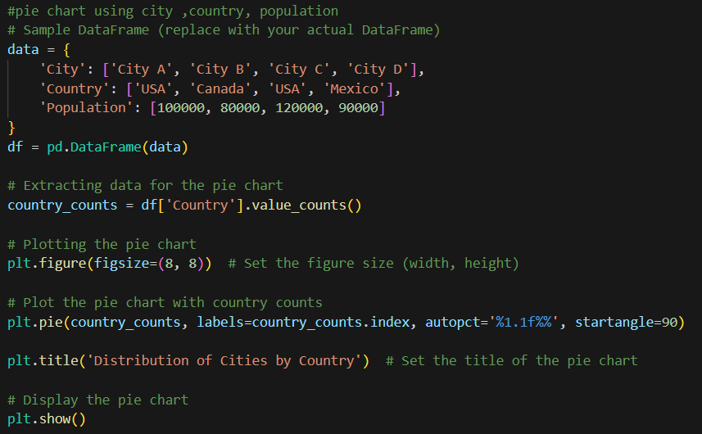

**OUTPUT:**

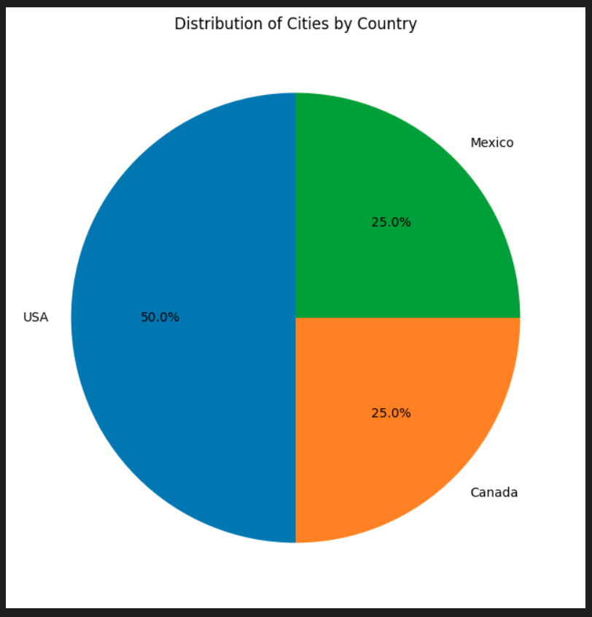

**GANTT CHART:**

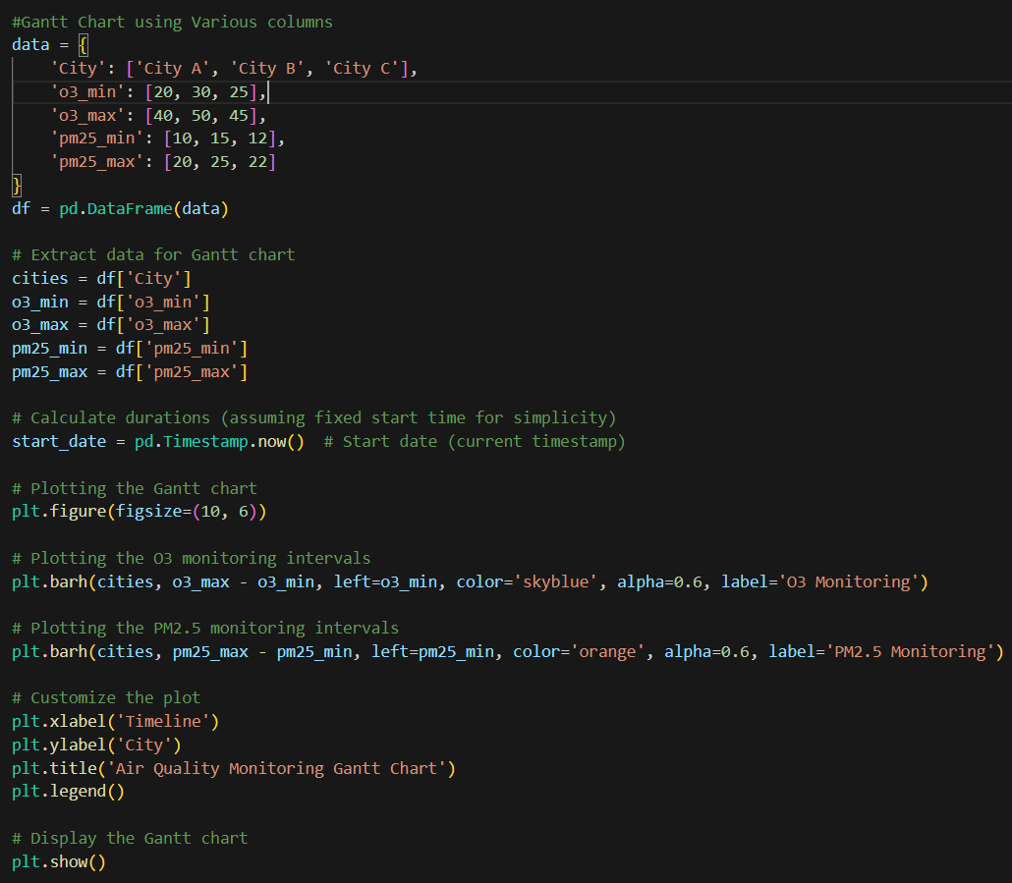

**OUTPUT:**

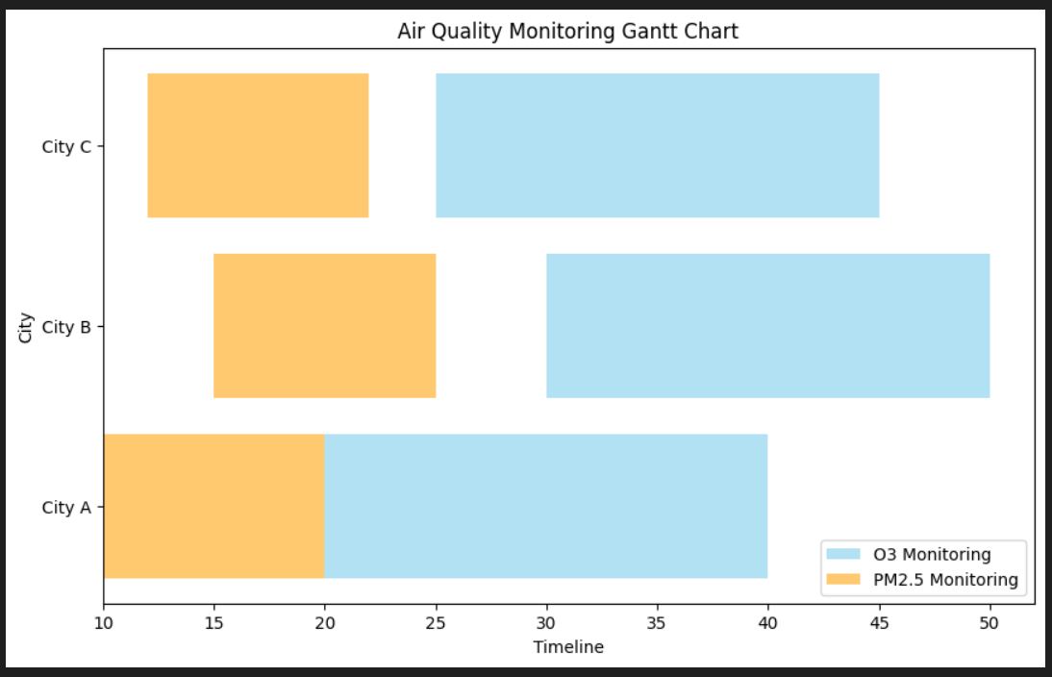

**CREATE MAP USING FOLLIUM:**

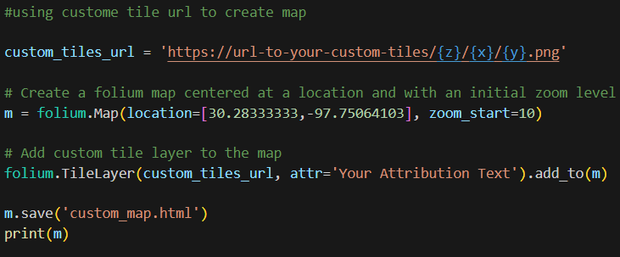

**OUTPUT:**

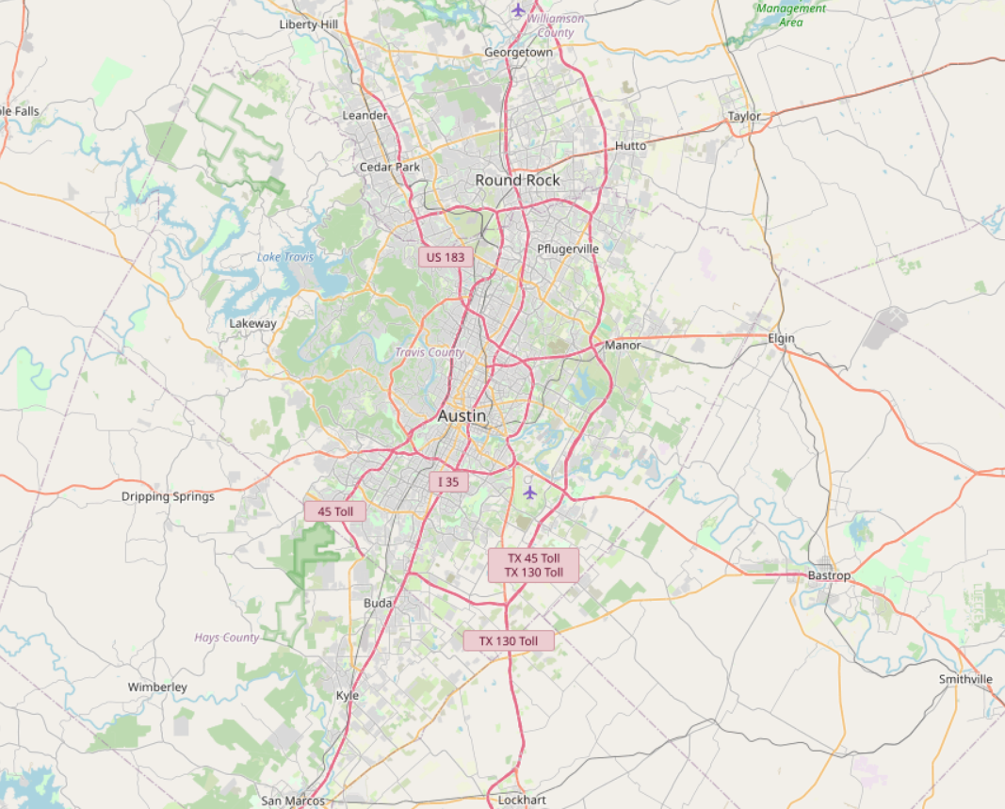

**GITHUB LINK:**

[**https://github.com/Rohith-034/Project**](https://github.com/Rohith-034/Project)